
INFORMATION SHEET FOR CHILDREN (6-8 YEARS OLD)

Ethical Clearance Reference Number:

Parents are encouraged to read out this information sheet.

Study for new Tablet Tasks

We want you to play some tablet games with us and help us with our study! We want to find out if children like you who are between the age of 6 and 8 years, enjoy these games.

What is a study?

Study is when we try to find out something new or learn something new.

What will I happen if I take part?

If you choose to help us, you will play games on a tablet and let us know if you like them! Playing the games will not take longer than an hour. In the game, you can travel into different worlds in a special machine, like the one shown below.



You will get to travel to different times e.g. the dinosaur era or a pirate era:
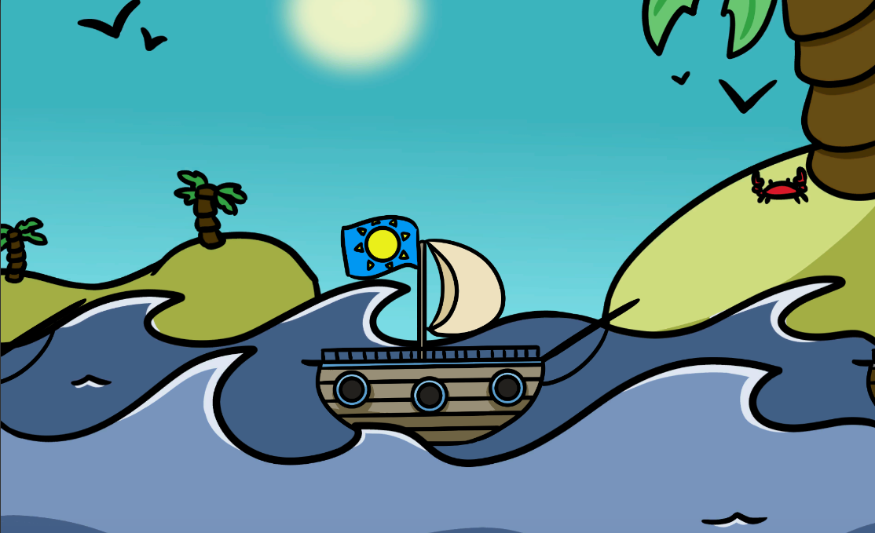
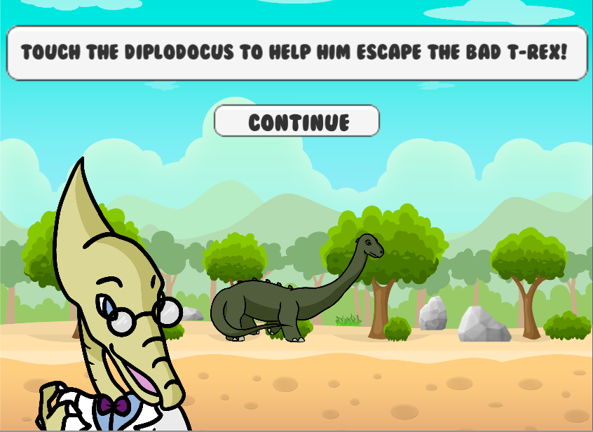

When you decide to play a game, Theo, a boy in the game will explain what you need to do. You can choose to play the games at school or at home, whatever you like more.
Do I have to take part?

You should only take part if you want to! if you prefer not to play the games that's fine, too.

What if I change my mind when playing?

You are free to stop playing the games at any point of the study, without having to give a reason. Just say you don’t feel like it and we can stop the study.

What do I do next?
You can think about the study and whether you want to take part. Your parents have a lot of information about the study so you can ask them about it. You can also ask our study team any questions.

If you agree to take part, you can write your name on the other form.

